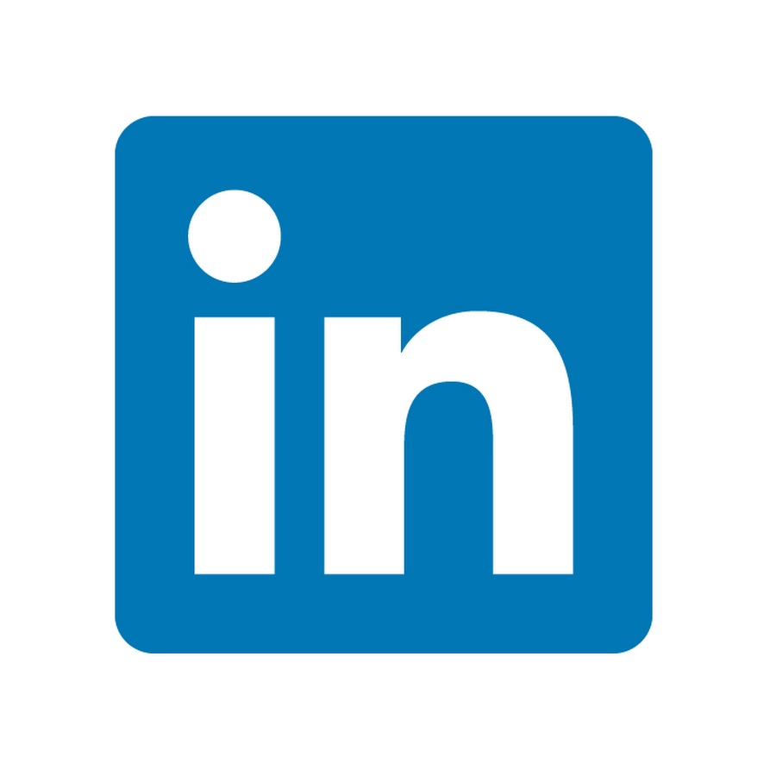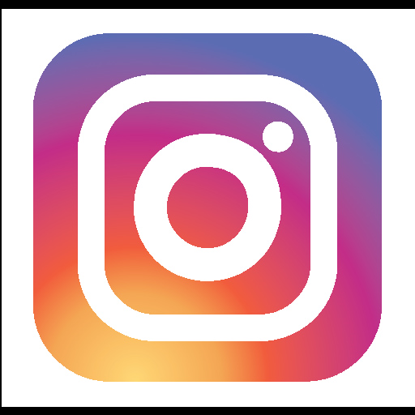

866.626.6836

www.contentthatworks.com

Ask us how we can help you get started making more ad revenue!

**Since we are the local experts, we know all the best spots to visit. We believe your local community knows the same about your town.**

**Have you thought about local native advertising?**

Help local businesses show off their valuable insights about your community through useful, knowledgeable content.

We are proud to call Charleston, S.C. home!

Welcome to

Charleston